**Photoelectric Effect**

Name : Hardik Shah

Roll No. : 16010221025

Branch : ETRX

Division : D2

**Aim:**  To understand the phenomenon Photoelectric effect as a whole.

To plot a graph connecting photocurrent and applied potential.

To determine the stopping potential for the photocurrent versus applied potential.

**Apparatus:** Voltmeter, Rheostat, Battery, Light source, Anode Material.

**Diagram:**

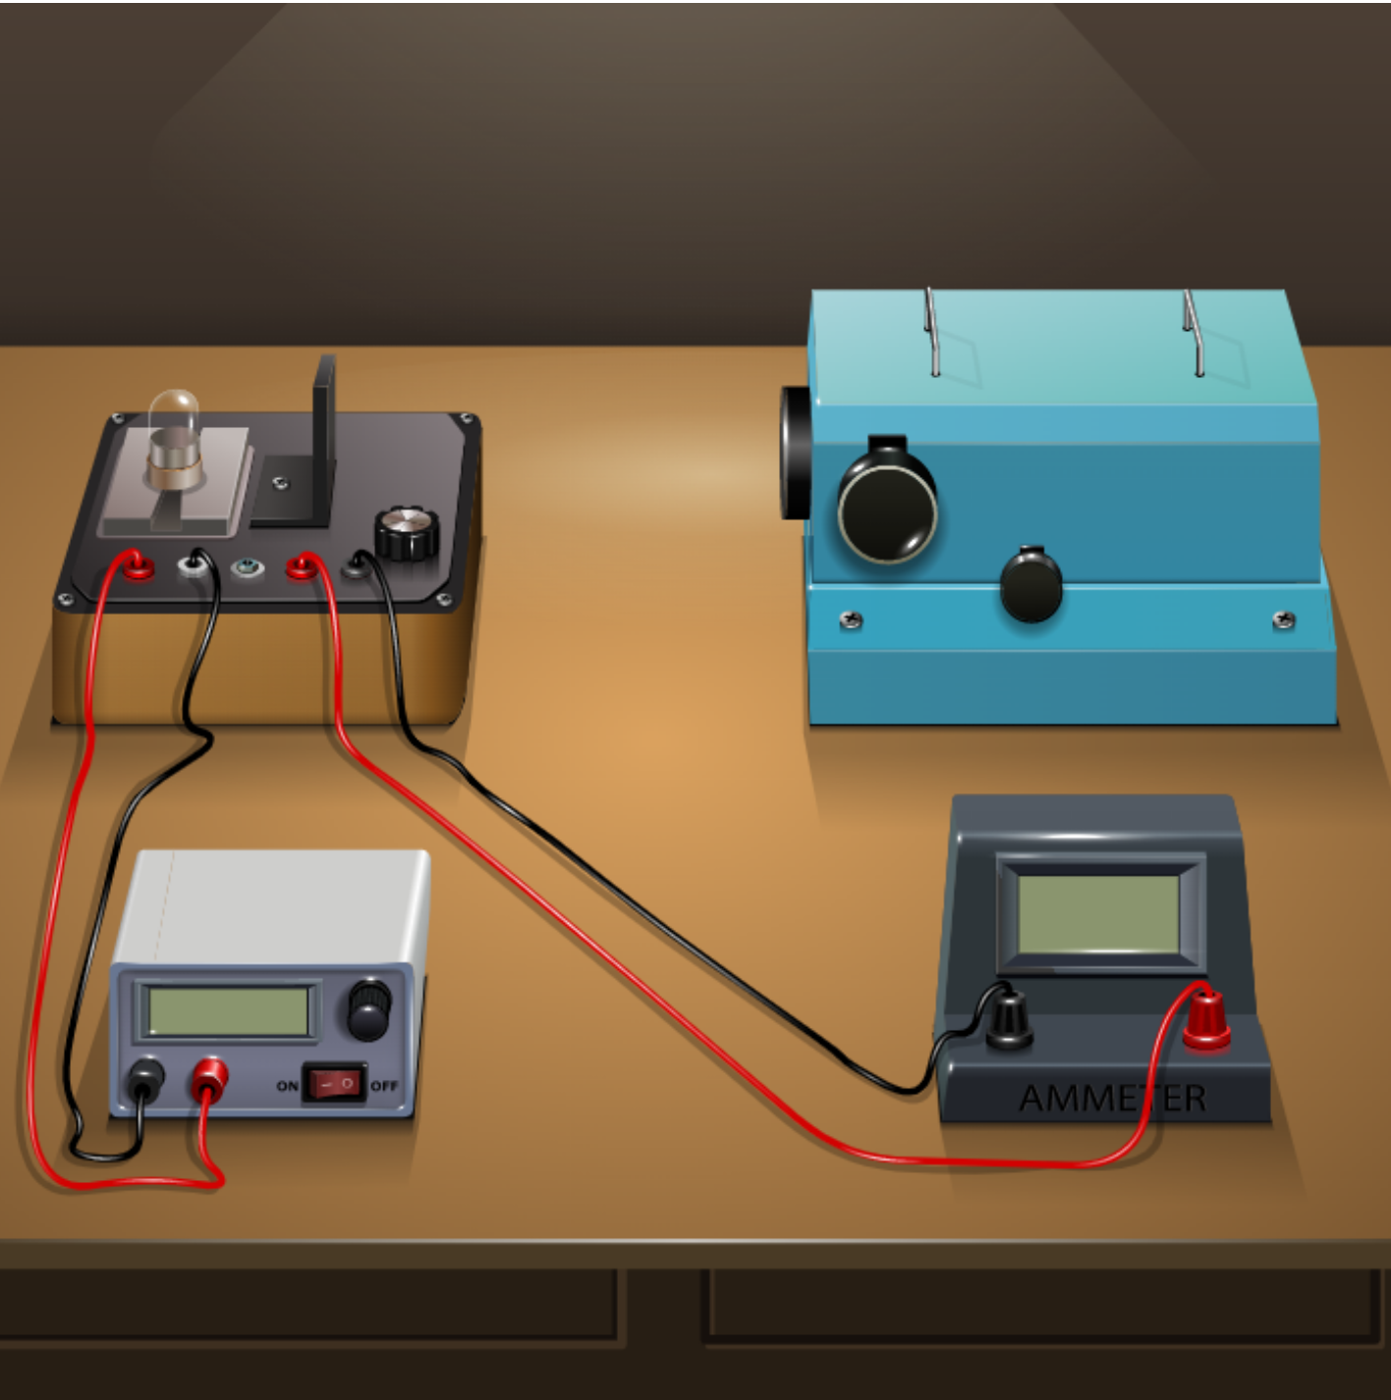

**Observation Table:**

Material: Sodium Area of plates: 0.5 cm2

**PART I: Fixed wavelength, varying intensity:**

|  |  |  |  |  |  |
| --- | --- | --- | --- | --- | --- |
| Wavelength: 150 nm (threshold wavelength = 500 - 600nm) | | | | | |
| Intensity = 15 W/m2 | | Intensity = 20 W/m2 | | Intensity = 25 W/m2 | |
| Voltage (V) | Current (µA) | Voltage (V) | Current (µA) | Voltage (V) | Current (µA) |
| 0 |  | 0 |  | 0 |  |
| -1 | 37.48 | -1 | 49.97 | -1 | 62.46 |
| -2 | 29.98 | -2 | 39.97 | -2 | 49.96 |
| -3 | 22.48 | -3 | 29.97 | -3 | 37.46 |
| -4 | 14.98 | -4 | 19.97 | -4 | 24.96 |
| -5 | 7.48 | -5 | 9.97 | -5 | 12.46 |
| -5.5 | 3.73 | -5.5 | 4.97 | -5.5 | 6.21 |
| -6 | 0 | -6 | 0 | -6 | 0 |

**PART II: Fixed intensity, varying wavelength:**

|  |  |  |  |  |  |
| --- | --- | --- | --- | --- | --- |
| Intensity: 30 W/m2 | | | | | |
| Wavelength = 200 nm | | Wavelength = 300 nm | | Wavelength = 400 nm | |
| Voltage (V) | Current (µA) | Voltage (V) | Current (µA) | Voltage (V) | Current (µA) |
| 0 | 58.92 | 0 | 27.88 | 0 | 12.36 |
| -1 | 43.92 | -0.5 | 20.38 | -0.1 | 10.86 |
| -1.5 | 36.42 | -1 | 12.88 | -0.2 | 9.36 |
| -2 | 28.92 | -1.2 | 9.88 | -0.4 | 6.36 |
| -2.5 | 21.42 | -1.4 | 6.88 | -0.5 | 4.86 |
| -3 | 13.92 | -1.6 | 3.88 | -0.6 | 3.36 |
| -3.5 | 6.42 | -1.8 | 0.88 | -0.8 | 0.36 |
| -4 | 0 | -2 | 0 | -1 | 0 |

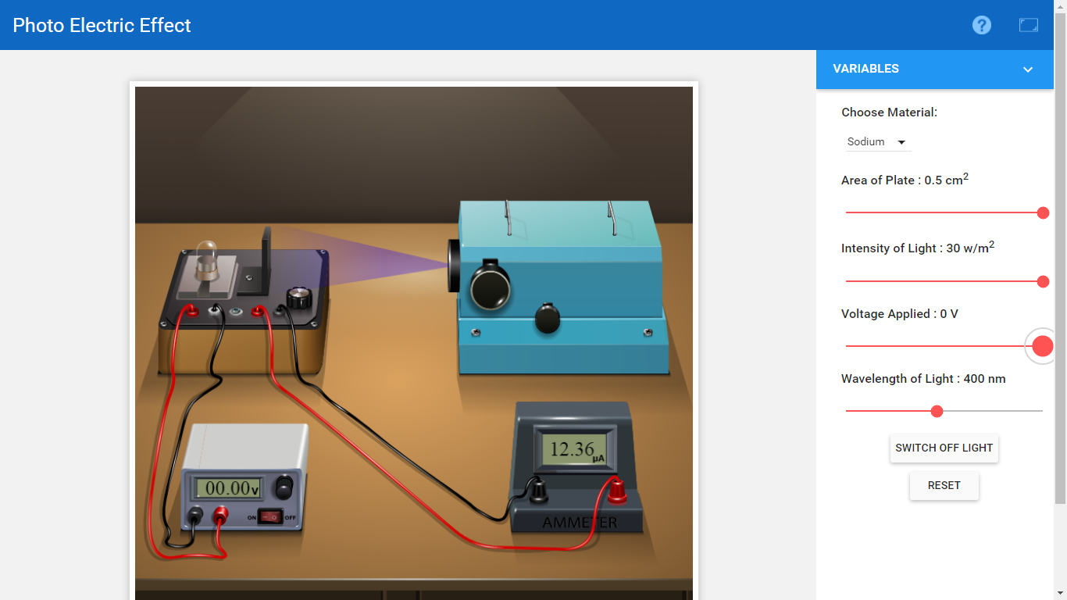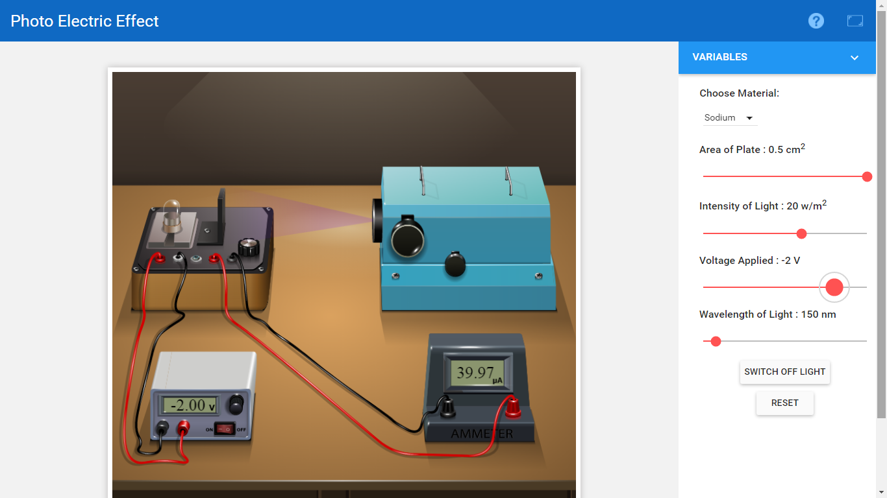

Graphs:

1. Voltage (X-axis) v/s current (Y-axis) for different intensities.
2. Voltage (X-axis) v/s current (Y-axis) for different wavelengths.

